Your 7 point guarantee for quality and value for money

At Fashion Clubwear, we are all about high quality garments at good “value-for-money” prices. However, it is one thing to say it, it is quite another to put it in writing. That is why we give you this 7 point guarantee.

- Fashion Clubwear guarantees to beat any written quote by 5 % on any Australian manufactured garment.
- Fashion Clubwear guarantees the colour fastness and dye quality of all garments. Our garments do not fade and are colour fast.
- Fashion Clubwear guarantees the consistency of size of all garments from order to order, no matter what the style. Our garments fit.
- Fashion Clubwear guarantees the workmanship of all garments. All garments are inspected thoroughly by our highly experienced QA team. They are made to last.
- Fashion Clubwear guarantees consistency of availability of your garments. Yes, they will be available next year.
- Fashion Clubwear guarantees the colour consistency of your garments from order to order.
- Fashion Clubwear guarantees that only the best quality yarns, inks and embroidery threads are used in our manufacturing process
or
we will replace or repair any item until you are fully satisfied.
Picture of Andrew Minter

Andrew Minter
Managing Director

ABN: 28 005 957 004
1-13 Shierlaw Ave, Canterbury VIC 3126
Telephone: (03) 9836 3388
Facsimilie: (03) 9836 3057
Email: info@fcw.com.au

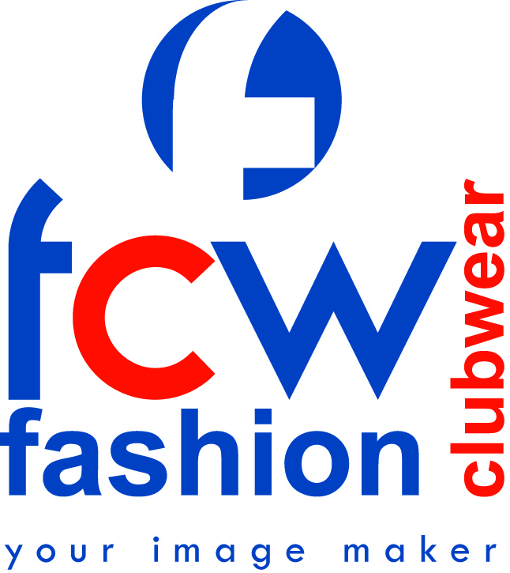

FASHION CLUBWEAR
GUARANTEE

Fashion Clubwear guarantees to beat any written quote by at least 5% on any Australian manufactured garment.

ABN: 28 005 957 004
1-13 Shierlaw Ave, Canterbury VIC 3126
Telephone: (03) 9836 3388
Facsimilie: (03) 9836 3057
Email: info@fcw.com.au

FASHION CLUBWEAR DELIVERY GUARANTEE

Fashion Clubwear guarantees to deliver your order within 4 weeks.

If we don’t we give you 5% off the invoice price.

EBA NO: AG2003/10562

Please note: the four weeks commences from your order or art sign off date

